**CASE STUDY ANALYSIS**

* **Anvitha Vadlamudi**

1. **Creating Virtual Machines**

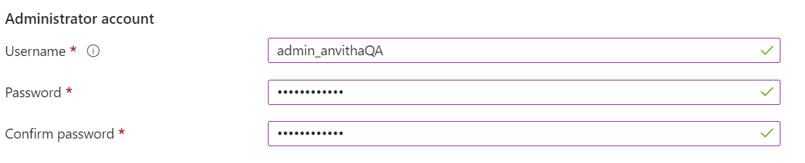

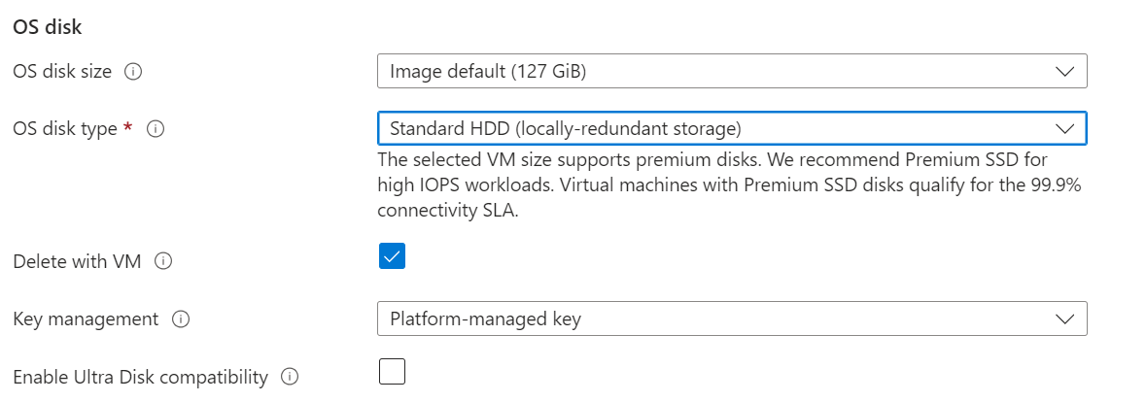

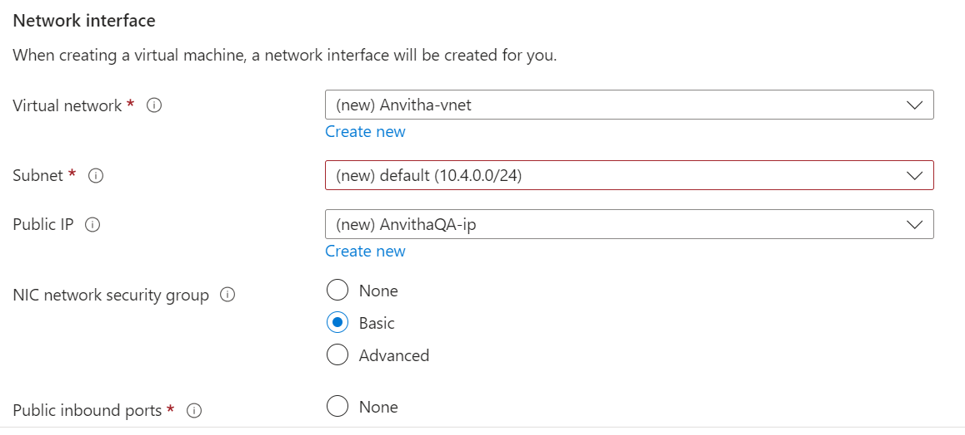

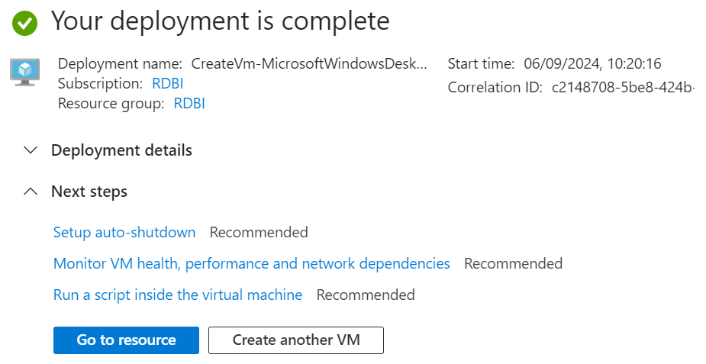

**2. Creating an epic**

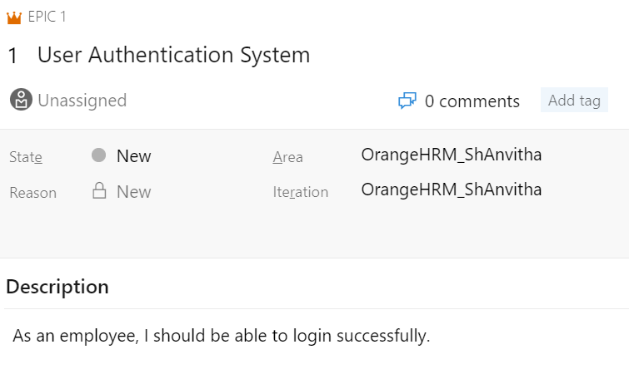

1. **Creating user stories**

These are all the user stories that I have created.

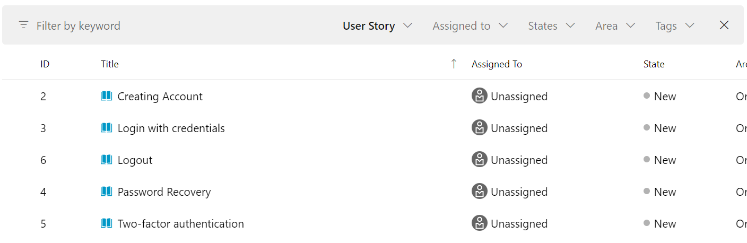

**Sample user stories are:**

1. **Creating tasks**

These are all the tasks that I have created for account creation user story.

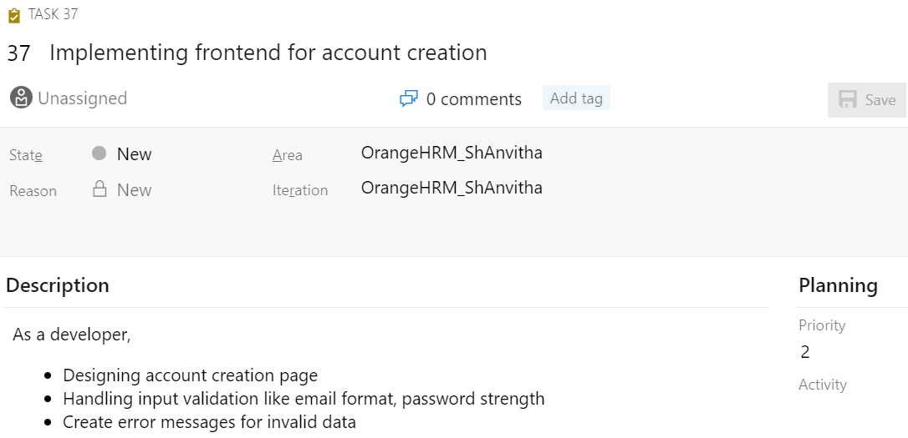

1. **Creating testcases**

I have created 25 test cases. 5 test cases for each user story. Few of them are here:

Sample testcases are:

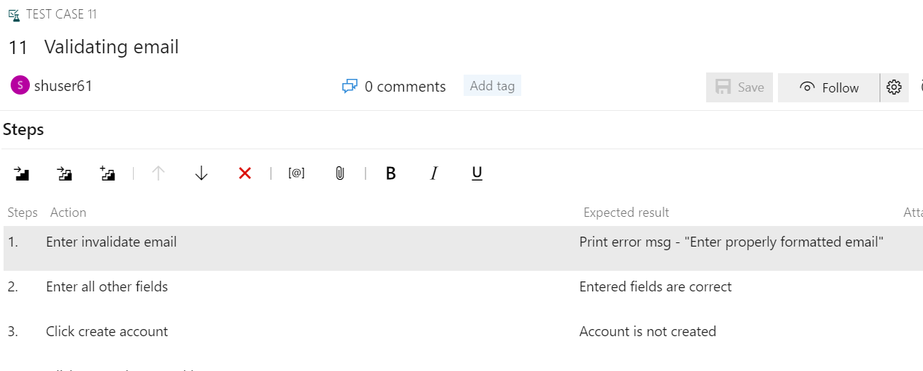

1. **Creating defect reports**

These are all the bugs that I have identified.

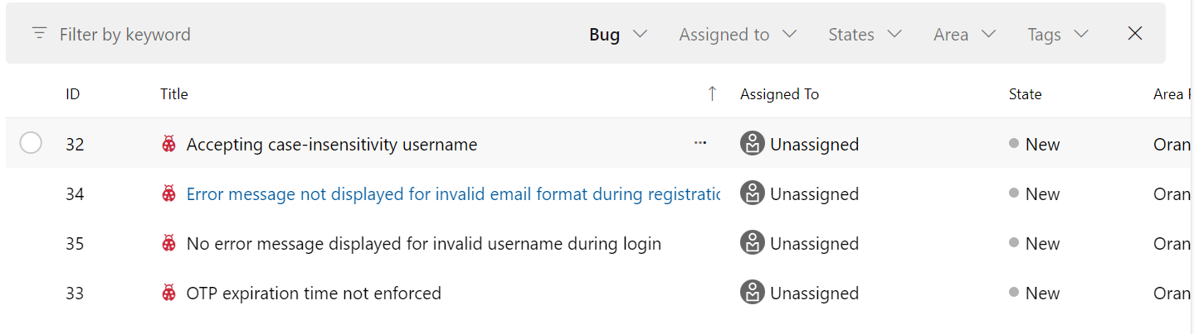

Sample bugs are:

**Github Actions**



